Keith Lopez

CMST386 6380

Project 2: WebSite Proposal

**Client and Topic:**

The website project I have chosen will be for a non-profit organization: Native-languages.org. The website is a great resource for those interested in the Native American culture and various languages of those tribes. Unfortunately, the website is hard to navigate as it appears it may not have been updated since its creation in 1998, as such my project will focus on integrating HTML5 elements and updating the design of the website.

**Development Process and Engagement:**

My research to rebuild this site will consist of two things:

1. Study the current layout and design of the website and identify current issues.
2. Examine multiple encyclopedia websites, like encyclopedia.com, Britannica.com and Wikipedia.com to understand the preferred layout for informational database sites.

I will develop my version of the site as a prototype which I will then submit to Laura Redish, site director and co-founder. Had I been an employee of this non-profit organization, I would assume we develop the upgrade using the agile development method: research, wireframing, design, prototyping, development, launch, etc. With the Redish and other stakeholder providing the requirements the new site needs to achieve.

**Testing:**

Prior to launch I will test all links and scripts work as intended on three different browsers I have installed on my machine: Internet Explorer, Google Chrome, and Mozilla Firefox. Additionally, I have cloud storage, I can access the prototype via my phone and check mobile functionality. Once functionality of the protype is verified, I will have friends and family perform a peer review of the website. This will help identify any issue I may have missed during my assessment.

**Description:**

[www.native-languages.org](http://www.native-languages.org/) is a small non-profit website that works in the preservation and promotion of the Native American languages and culture. The website is a repository of information containing vocabulary words, stories, mythologies, and enormous amounts of links to various online resources. The site appears to be intended for any person of any age with interest of the Native American Culture and language.

My prototype aims to give the website a general appeal as presently the website pages are a wall of text and difficult to navigate through. This can be off-putting to any user attempting to find any information on the website. As the site already contains a lot of information, I will be using many of its resource to rebuild the webpages as my focus will be primarily on redesigning the websites layout. I may, however, need to use to relatable images to break up text walls. I do not suspect the pages requiring a lot of updating unless new information becomes available.

**Growth and Maintenance:**

I anticipate the site will continue to add new pages or edit older pages as new information is gathered and added. As I develop the prototype, I will develop an article template with a comment section of where to add the content whenever they are ready to deploy a new page. I would prefer to have the site link back to a database like MySQL or Oracle to help website upkeep and ease site scalability. Lastly, I will also utilize a CSS preprocessor to develop the external stylesheet to assist with maintenance tasks as native-languages.org is currently utilizing inline styles.

**Organization**:

The website is presently organized in a hierarchical model. This is the best model for this type of website as it contains lots of information; it makes it easier to organize and find content. My prototype will maintain the same structure as in Figure 1, however, my aim is to simply make the categories more accessible to visitors and I will add breadcrumb navigation to the article pages so users can backtrack. As it stands the pages on native-languages.org are a wall of text and hard to navigate through.

Figure . Prototype Hierarchical Diagram

My prototype will contain design 3 different webpage templates: the home page, the articles pages, and the disclosure pages. The disclosure pages will contain all “non-content” information that users are likely not searching for such as the privacy policy, FAQs and the about us summary. Below are examples of the proposed prototype design along with screenshots of native-langages.org current website design as of June 12, 2021.

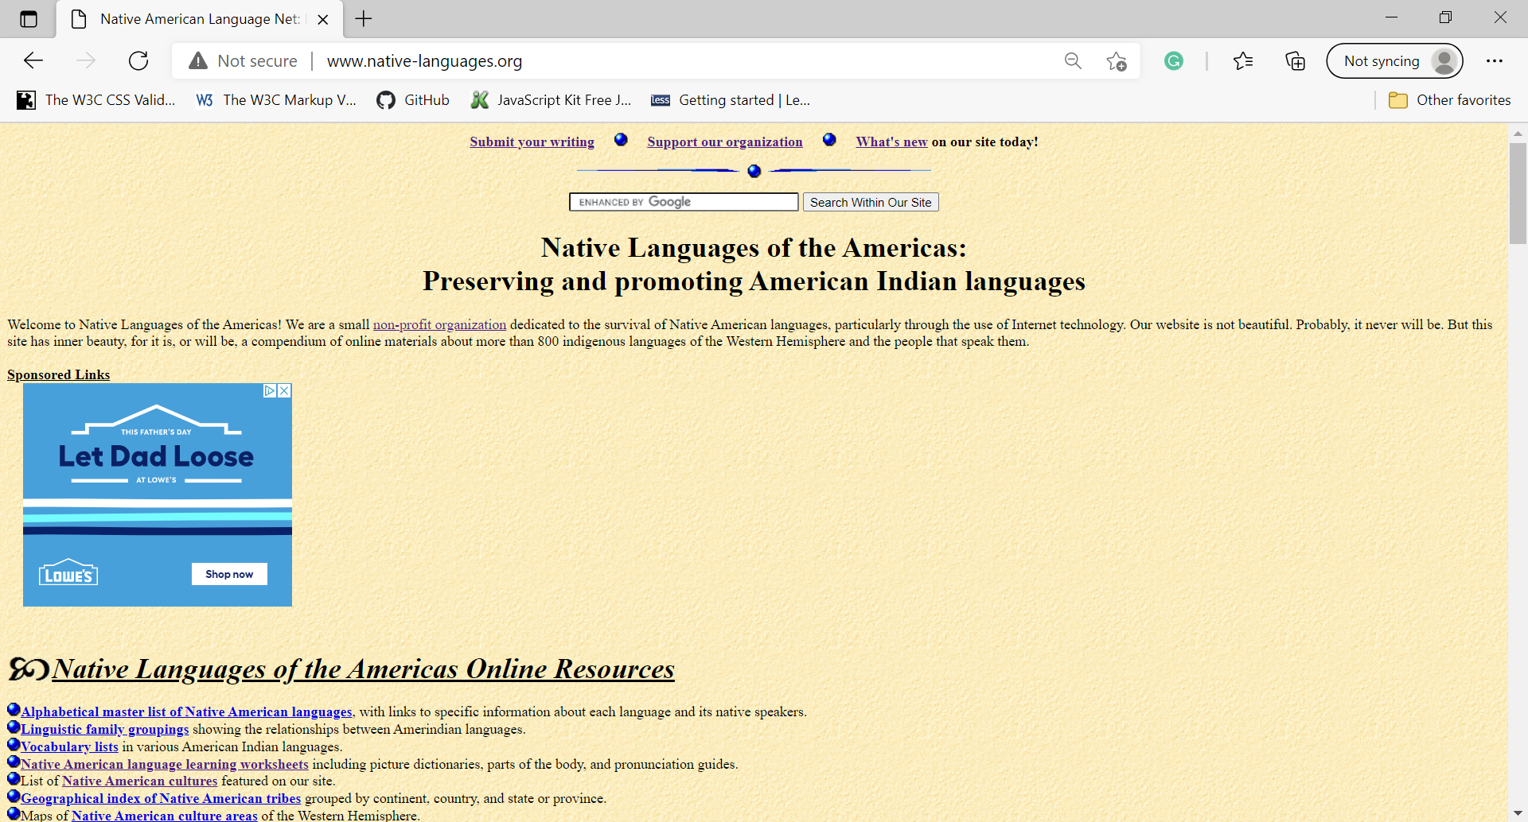

Figure . Current Home Page

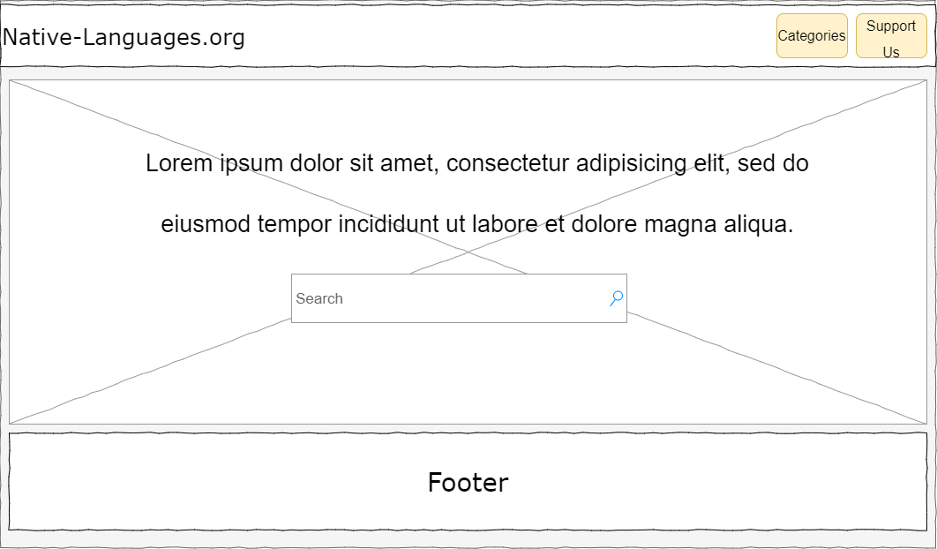

Figure . Prototype Home Page Wireframe

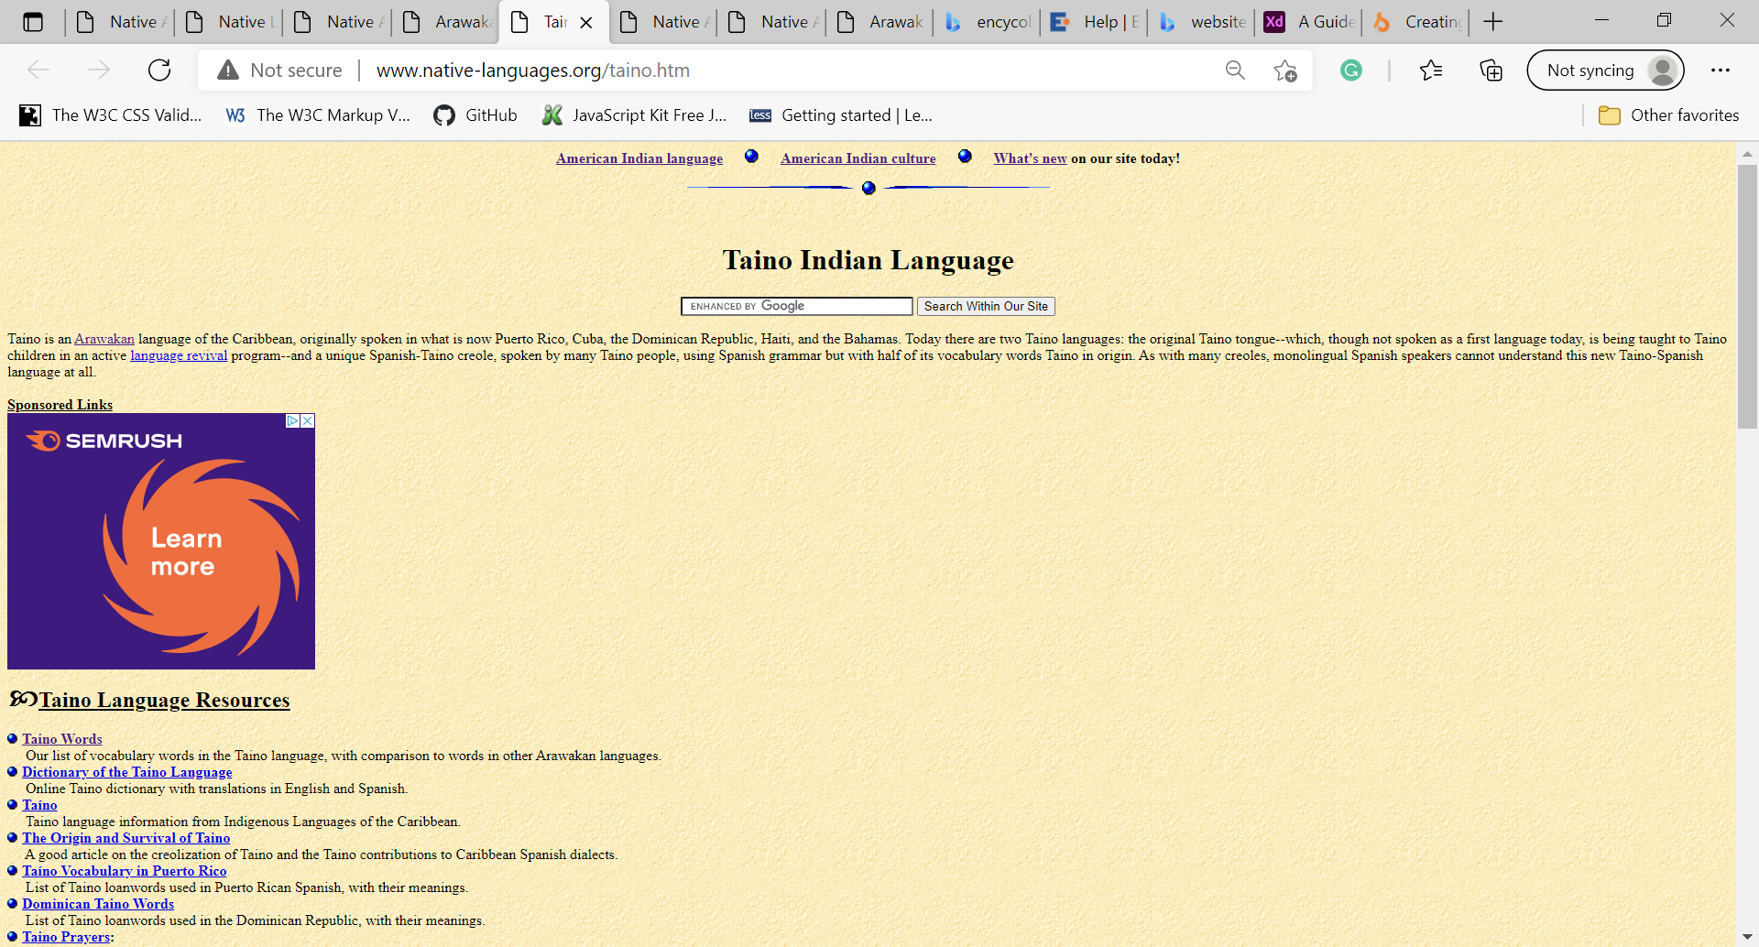

Figure . Current Article Page

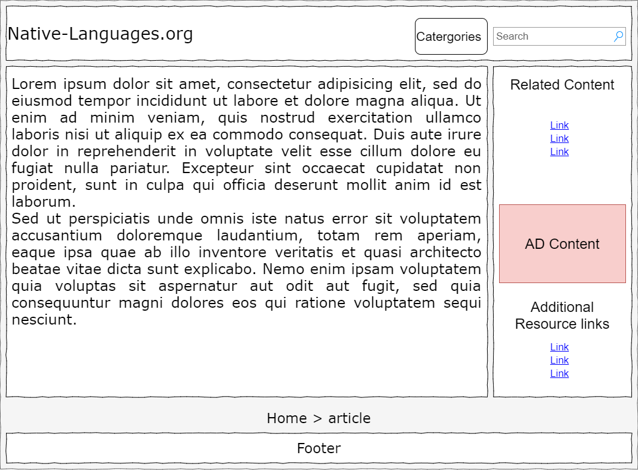

Figure . Prototype Article Page Wireframe

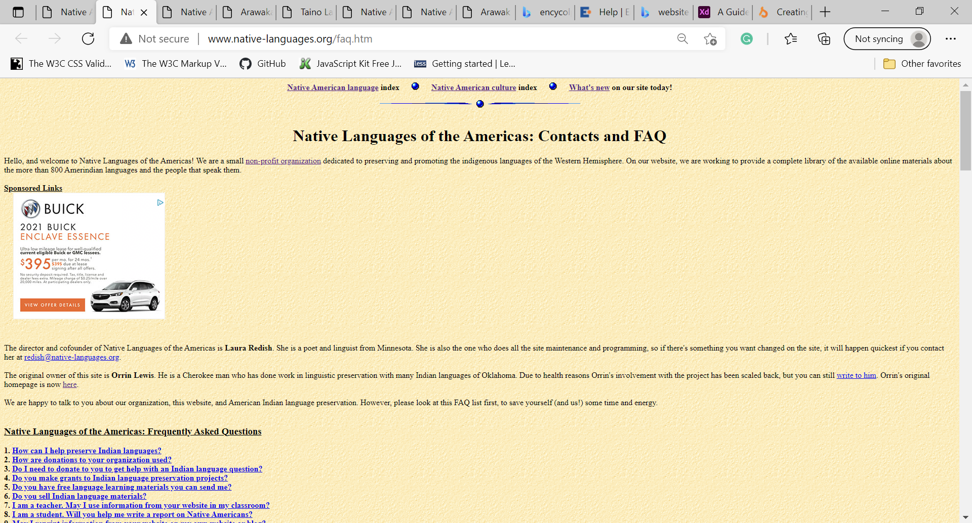

Figure . Current Disclosure Page/ About us & FAQ

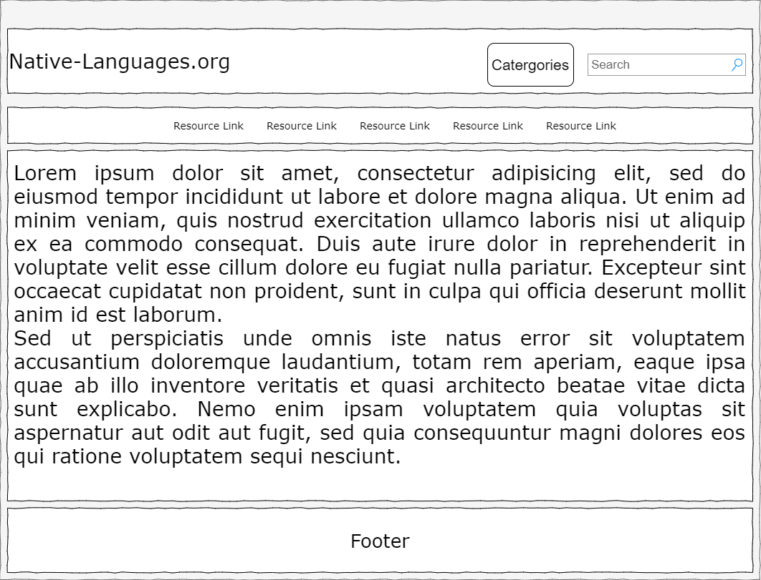

Figure . Prototype Disclosure Page Wireframe

**Security:**

The protype will not have an e-commerce component as the current site does not have one neither. Nor will the site need a password protection feature. As it stands site content is dedicated by the site owners requiring users to submit their works directly to them for review and possible integration.

**Web Hosting:**

The Native-Languages website is primarily focus is of an informational site. As the site is expected to contain lots of data and expand over time the web hosting solution needs to contain elements like ample data storage capacity, 24-hour support and back-up and restore features. Another element to consider would be having access to a database like MySQL would be an added benefit as this would allow users to search queries much faster and site scalability and upkeep easier (Designbeep Staff, 2018). According to [www.whois.com](http://www.whois.com), the website is currently utilizing Yahoo for its hosting services and when compared to other popular web hosting services such as GoDaddy.com, Domain.com and HostGator.com, Yahoo fits most of the solutions required at a decent cost:

|  |  |  |  |  |  |
| --- | --- | --- | --- | --- | --- |
| Web Host | Price* | Storage | Back-up/Restore | Databases | 24/7 Support |
| Hostgator.com | $4.48/mo | Not listed | Not Listed | Not listed | Included |
| Domain.com | 13.75/mo | Unlimited | Included | Unlimited | Included |
| GoDaddy.com | 20.99/yr for org domain | Not listed | Not listed | Not listed | Not listed |
| Yahoo | 5.22/mo | Unlimited | Included | Not listed | Included |
| *All prices listed from the highest plans available per web hosting services on June 11, 2021. | | | | | |

**Marketing:**

Keyword optimization, content organization and inbound links will be essential for the marketing of this website. The protype I plan to build will reorganize the content and integrate keywords like Native American languages, Native American Indian languages, or Native American Indian History in the meta tags when viewing the page source in Internet explorer.

**REFERENCES**:

Designbeep Staff. (2018, June 27). 5 Benefits of Using MYSQL. Designbeep. http://designbeep.com/2018/06/23/5-benefits-of-using-mysql/.